PROGRAMMING FUNDAMENTALS
LAB TASKS 04

TASK 1:
CODE:
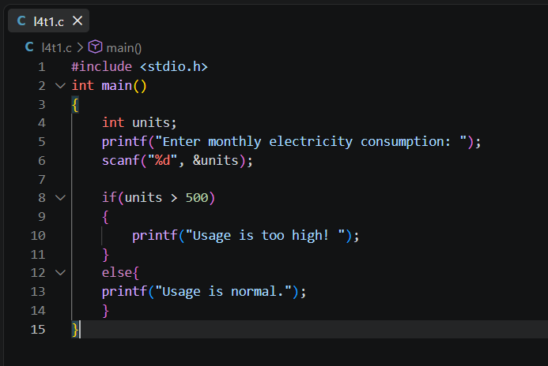
OUTPUT:
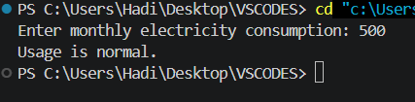

TASK 2:
CODE:
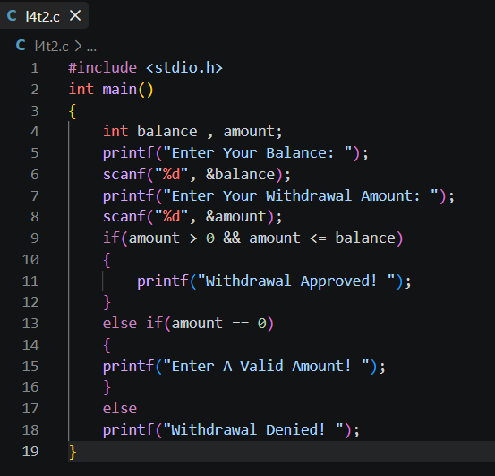
OUTPUT:
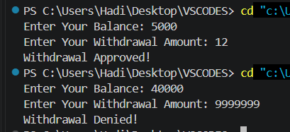

TASK 3:
CODE:
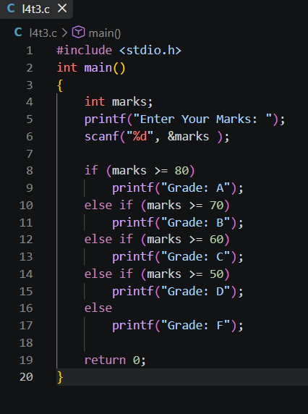
OUTPUT:
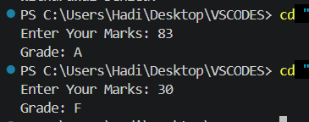

TASK 4:
CODE:
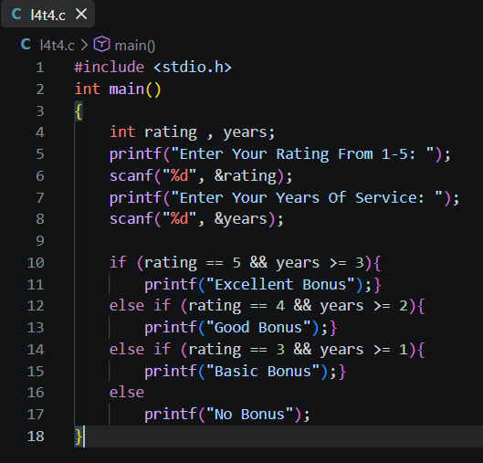

OUTPUT:
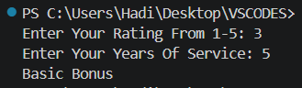

TASK 5:
CODE:
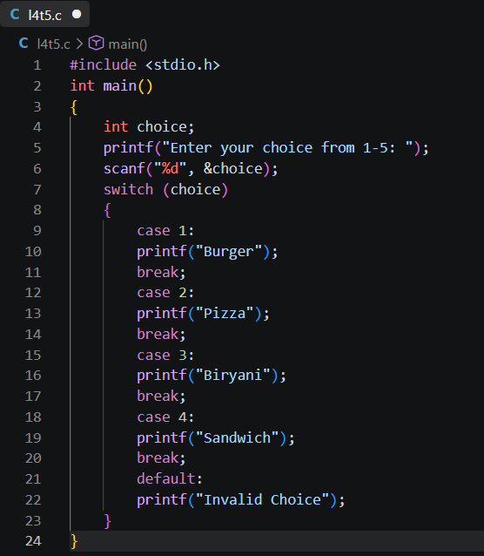
OUTPUT:
